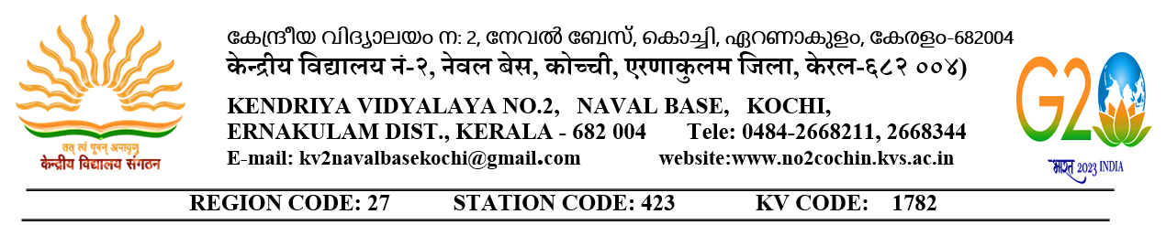

केन्द्रीय विद्यालय में संविदा शिक्षकों के लिए वाक इन इंटरव्यू

WALK-IN-INTERVIEW FOR CONTRACTUAL TEACHERS IN
KENDRIYA VIDYALAYA-2023-24
CORRIGENDUM TO ADVERTISMENT DATED 04.02.2023
The date of walk -in-interview for the post of Trained Graduate Teacher (TGT) on contractual basis to be held at KV NO2 Naval Base Kochi, is rescheduled on 25.02.2023 instead of 23.02.2023 at 09.00 AM. Rest no change.

PRINCIPAL
NB: Candidates should fill in the biodata form and bring it on the day of interview

