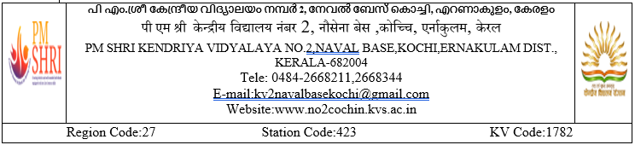

F. No.20 /KV2 CHN/2024-25 दिनांक:26.08.2024

**प्रवेश सूचना 2024-2025/ADMISSION NOTICE 2024-2025**

**रिक्त सीटों पर प्रवेश: /ADMISSIONS AGAINST VACANT SEATS:**

Applications are invited against a few vacant seats available in class 2 and class 3 in PM SHRI KV No 2 KOCHI. Interested parents can get the admission registration form free of cost form the school on 27.08.2024 between 09.00 AM to 02.00 PM and the registration forms complected in all respects with required documents to be submitted on 29.08.2024. Admission will be given as per the rules of KVs. Incomplete application forms shall normally be rejected. Claims unaccompanied by certificate will not be considered.

Mere applications will not entitle any candidate for admission. Admissions will be done as per KVS Admission guidelines. (2024-25)

**आवश्यक दस्तावेज़/Documents required**

1. Registration form
2. Birth Certificate of child
3. Certificate of number of Transfers
4. Proof of Residential certificate.
5. Passport size photograph.
6. Caste Certificate SC/ST/OBC (if claimed).
7. Aadhar Card (Self attested photocopy)
8. Service certificate issued by the competent authority.
9. Any other document if claimed (Games & Sports/ Scouting & Guiding/ NCC/ Adventure activities etc at regional/state/National level as given in KVS Admission Guidelines 2024-25).

**प्राचार्या/PRINCIPAL**